Running this app in my desktop and as you can see there are multiple try to get the correlation correct,

Taken this example from the below website,

Reference: https://gallery.shinyapps.io/correlation_game/

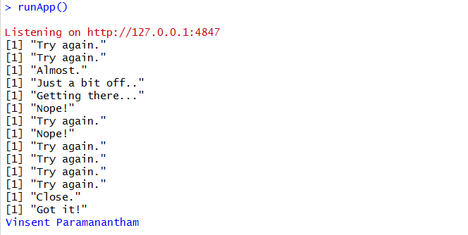

The below is the screen shot of APP running in my machine(locally)

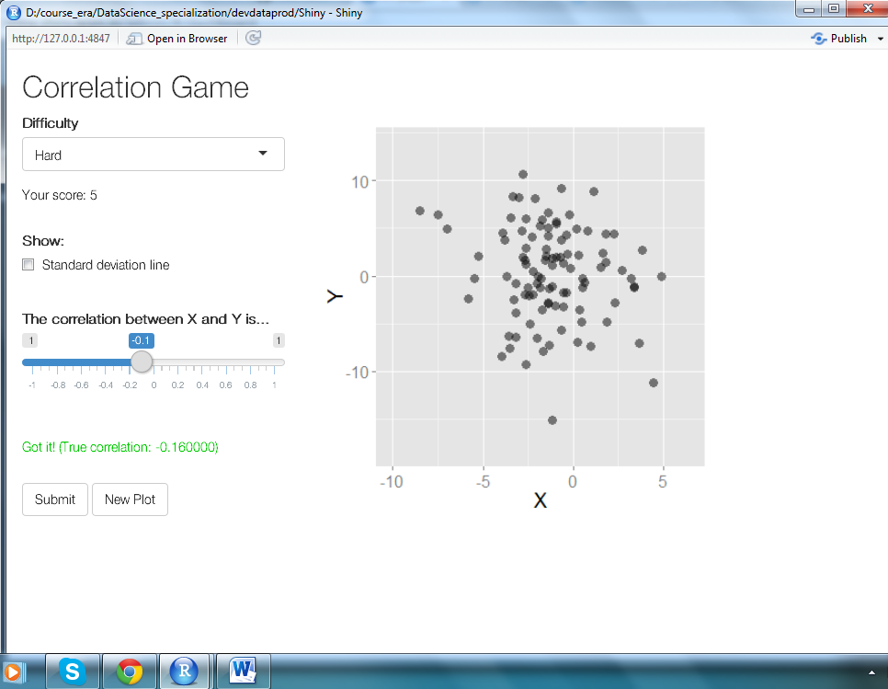

A wrong guess on the correlation for X and Y

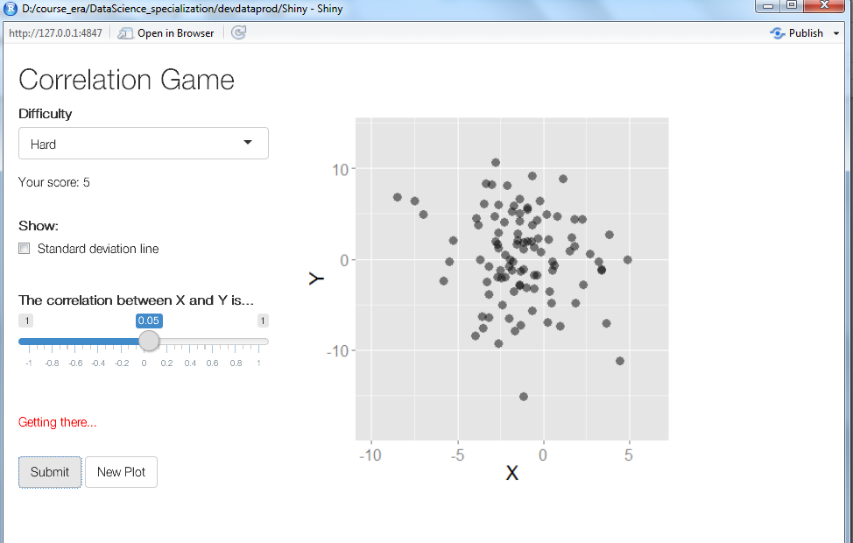

Deployed in [www.shinyapps.io](http://www.shinyapps.io), <https://vinace.shinyapps.io/Shiny>

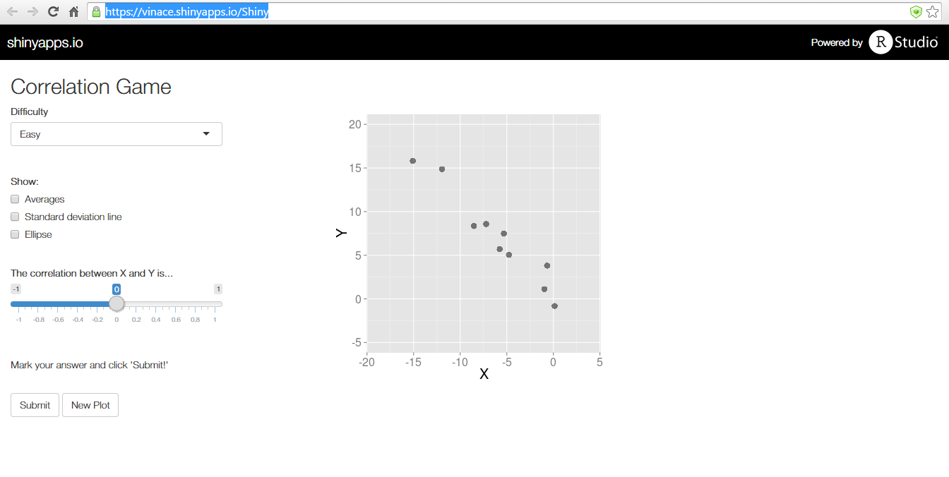

Attaching the server.R and ui.R script to the Git hub.